|  |  |  |  |
| --- | --- | --- | --- |
| **Project Charter** | | | |
| **Project Name:** | Project 2 | **Project Manager:** | Group 12 |
| **Approval** |  | **Date:** | 3rd March 2021 |
| **Project Owner** |  | **Version Number:** | 1 |

**Table of contents**

1 Introduction / Management Summary 1

2 Goal of the project (S,Q,T,B) 2

3 Project Scope (S) 2

4 Approach (S,Q,T,B) 3

5 Quality (Q) 3

6 Time and effort (T) 3

7 Outline Business Case (B) 3

8 Risks and assumptions (R) 3

9 Organization (O) 3

# Introduction / Management Summary

* This Project is about the planning, designing and creating of an airplane ticket and booking service.
* **Purpose:** The purpose of this project charter is to describe on a high level the detailed information on the <<Project 2>> project. It is to clearly specify goals, budget, scope, approach and time and effort constraints of the project.
* **Advice:** Based on the analysis carried for this Project Charter the proposal is to put importance on the user experience, to make it as fluent and easy as possible.

# Goal of the project (S,Q,T,B)

* The goal of this project is to create an easily-navigable and easy to understand application for employees of an airplane company to efficiently book flights for customers and thus increase the revenue of the company.

## Background information

* This project is to assist in the infrastructure of said airline, as it is a highly customer-rich business, operating only on the transportation of customers from point A to point B.

# Project Scope (S)

* The scope of this project is defined by the client’s and the stake holders’ criteria and requirements. As of right now, they include the information from the first contract, but are subject to change upon further talk with the client and the stakeholders.

## Project definition

* The project needs to achieve an application that fulfills multiple criteria set by multiple actors.

There has to be an usable interface, which allows Sales employees to lookup available flights and create bookings for these flights for one or more customers, allows Sales managers to overview statistics and allows Sales officers to register flights and create static and dynamic price reductions.

The bookings created by Sales employees are able to have options concerning for example extra legroom, food, luggage or seats chosen.

The application also needs to calculate the prices with the information from the bookings, options and the possible price reduction.

It needs to support multi-user access and not cause interference due to multi-user operation.

Finally, there should also be a management dashboard, for sales managers, showing key performance indicators such as total revenue numbers, tickets sold in each class and statistics on all options sold.

## Project scope and exclusions

On high level the following aspects will be impacted by the <<Project 2>> project:

|  |  |
| --- | --- |
| **Architecture aspect** | **Involved entities** |
| Organization | [Check all relevant stakeholders.] |
| Process | Process will be semi-automated via the interface. |
| Information | Information about Bookings, Options and more is stored and displayed in the management dashboard. |
| System |  |
| Infrastructure | The application will be integrated into the whole airline infrastructure and allow and ease access to the rest of the infrastructure. |

**Not in Scope:**

* The program does not store information about the whole airline service, it only is to support the sales of flight tickets and help sales managers get an overview of them and statistics about them.

## Relations & interfaces

Below the main external relations and interfaces the <<Project 2>> project has to take into account:

* There will be a relation to an API to retrieve information for dynamic price reduction.
* There will be a relation to a payment service to handle payments, which may have to be done with an interface from that specific payment service.

Products and Services to be delivered:

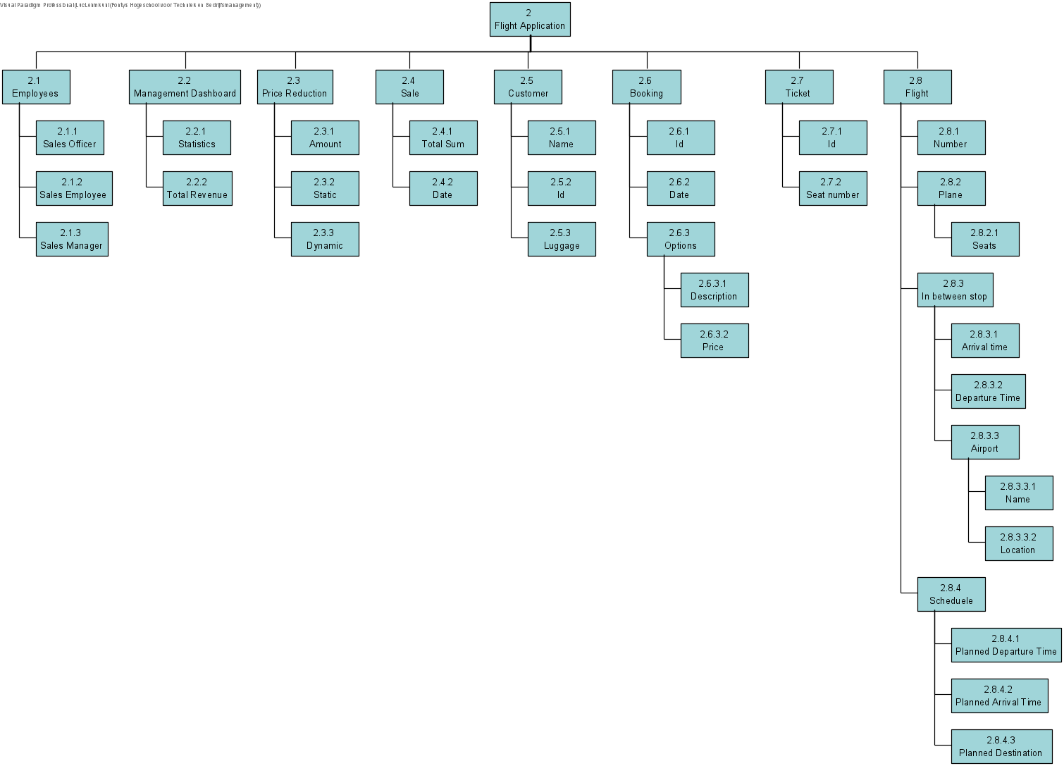

# Approach (S,Q,T,B)

* During the whole project the client and the stake holders will be continuously informed and their input integrated into the development of the project. The project will first be planned through thoroughly. After these plans have been made and analyzed to be optimized and fit the project’s needs, implementation will start. The project will first create a foundation by implementing the underlying database, with which the whole program will interact later on. The database will be planned beforehand with different diagrams, such as an ER diagram and a relational model. After the database is done, the main application will be created and worked on. It will also be planned with various diagrams such as a mood-board and a navigational diagram. Whilst creating the application already created artefacts, such as the use case diagram, the use cases, the user stories and the domain model, will be kept in mind and closely followed throughout the whole process. After the application is functionally complete, it will once again be checked for bugs and overall improvements to be made. After those have been made the program is done and can be delivered to the client.

# Quality (Q)

## Customer quality expectations

* All requested interfaces and programs implemented with an thought-through user experience.

## Acceptance criteria

* Management dashboard implemented
* Dashboard for Sales officer implemented
* Dashboard for Sales employee implemented
* Calculation of ticket prices implemented
* Storing of data for the Management dashboard implemented
* Login System implemented

## Prerequisites & Constraints

* Staying in the time frame and planning well enough to not have to go back and rework artefacts from prior project phases.

# Time and effort (T)

Based on the initial impact analyses the following estimates were derived on lead time and required effort to achieve the project goals:

|  |  |  |  |
| --- | --- | --- | --- |
| **Project phase** | **Lead time**  (start-end) | **Business effort**  (days) | **IT effort**  (days) |
| Start up and Initiation | Wk1-Wk4 |  |  |
| Sprints: (Design, Realization and Confirmation, deployment) | Wk5-Wk12 |  |  |
| Final deployment and go live | Wk12-Wk14 |  |  |

# Outline Business Case (B)

## Alignment with corporate strategy

As quoted above the main business drivers for <<Project 2>> are:

* Reduce complexity of the process
* Increase flexibility of the process
* Replace some repetitive man-handled tasks with automation handled by the system.

**Benefits**

* Savings on process step efficiency
* Savings on data entry and paper procedures
* Other benefits that are not easily expressed in money are
  + Increasing worker contentment.

**Costs**

The costs are grouped in these categories:

* Realization project costs (see section 6)
* Implementation costs
* Worker education costs
* Maintenance costs

## Project Tolerances

During its course a project is monitored and managed to stay within the Scope-Quality-Time-Budget quadrant (SQT€-quadrant). Preliminary measurable definitions and their tolerances for Scope, Quality, Time and Budget are given in this document. Once a detailed planning is worked out as part of the Project Initiation Document (PID) the final tolerances will be described. As soon as it becomes clear that one of the tolerances is going to be exceeded the Steering Cie. will be involved.

Scope : Change management on the scope list can be applied in case of setbacks in e.g. realization or implementation. Also working out in more detail the process steps and their realization in the system can lead to refinements in the vision on the concepts. When one of these events occur an exception report will be prepared for the PSC, by which the PSC has to decide on the scope change.

Quality : No critical system or process issues are open at stage boundaries and at project closure. The list of non-critical open issues must be approved by project steering cie. and accepted by the demanding customer at project closing.

Time : A standard value for a maximal deviation from a project planning is 10 %. Given the fact that for the proposed changes concepts and processes have to be re-thought a larger tolerance may be required. If this appears to be so, it will be motivated in the Project Initiation document when the project plan has to be approved.

Budget : the budget may not exceed the amount approved in the PID, or amendments on that amount approved by the project steering cie, by more than 10 %.

# Risks and assumptions (R)

During the investigation for this Project Charter several risks were mentioned:

* Being too short on time due to underestimation of certain artefacts.

# Organization (O)

**Initial resourcing of project:**

* Project St. Cie xxx
* Executive/Project Owner xxx
* User xxx
* Supplier xxx
* Project Manager: xxx

**Involved people:**

* Clients: xxx
* End users: xxx
* Other involved: xxx